**Analytical case study**

**Q1**

**Query (1)**

select country,count(stockcode),rank()over(order by count(stockcode)desc )from online_retail

group by 1

**Story :**

we find united kingdom have The largest number of goods of various kinds which led to an increase in the number of customers coming here.

**---------------------------------------------------------------------------------------------------**

**Query (2)**

select distinct description, country,sum(Quantity*unitprice)

over(partition by description,country rows between unbounded preceding and

unbounded following ) as sales

from online_retail

order by 3 desc;

**story:**

during analysis , we find the product that achieve high sales rate , we find united kingdom

occupies the first position for products may be in united kingdom There are many branches / stores.

**Query (3)**

select *,rank()over(order by sales desc)

from(select distinct country,sum(quantity*unitprice)over(partition by country

rows between unbounded preceding and unbounded following) as sales

from online_retail

order by 2 desc

)as base

**Story:**

during analysis this data , I find the most sales in total happens in

united kingdom , and the sales in this country is very high than other countries.

**----------------------------------------------------------------------------------------------------**

**Query (4)**

select country ,extract ( month from cast(invoicedate as date))as month,max(quantity*unitprice)

over(partition by cast(invoicedate as date),country) as sales

from online_retail

where country='United Kingdom'

order by 3 desc

**story :**

relation between months and sales .. we find the sales is very high ,in December comparing with the other months ,It may be according to the type of product that the customer buys, it may be related to the seasons of the year.

**Query (5)**

select *

from (select distinct description, unitprice, count(*)over (partition by description)

from online_retail

where country='United Kingdom'

order by 3 desc)as base

**Story:**

we find unit price of the most sale product changes many times..

may be this discount happen so this attractive.. we can prepare more offers

which lead to improve the business.

**Query (6)**

with invoice_cust_sales as

(

select distinct customerid,invoiceno

from online_retail

where country='United Kingdom'

order by customerid)

select * ,percent_rank()over(order by no_of_item)*100 as percentrank

from(

select distinct customerid,count(*)over(partition by customerid)as no_of_item

from invoice_cust_sales)as base

**Story:**

we find top customers , who makes a lot of invoices , so it improve business and profit

can suggest make a lot of offers for this kind of customer.

**Q2**

segment each customer based on the below groups Champions - Loyal Customers - Potential Loyalists – Recent Customers – Promising - Customers Needing Attention - At Risk - Cant Lose Them – Hibernating – Lost.

with RFM as (

select customerid,

(SELECT MAX(TO_DATE(invoicedate,'DD Mm YYYY') ) FROM online_retail)-

MAX(TO_DATE(invoicedate,'DD Mm YYYY') )as recency,

count(*)as frequency,

sum(quantity*unitprice)as monetary

from online_retail

group by customerid order by customerid

),calc_rfm as (

select cal_rfm.*,ntile(5) over(order by recency desc)as R_score,

ntile(5) over(order by frequency )as F_score,

ntile(5) over(order by monetary )as M_score

from RFM cal_rfm)

select r.*,

(case when R_score=5 and (F_score+M_score)/2=5 then 'Champion'

when R_score=5 and (F_score+M_score)/2=4 then 'Champion'

when R_score=4 and (F_score+M_score)/2=5 then 'Champion'

when R_score=5 and (F_score+M_score)/2=2 then 'Potential Loyalists'

when R_score=4 and (F_score+M_score)/2=2 then 'Potential Loyalists'

when R_score=3 and (F_score+M_score)/2=3 then 'Potential Loyalists'

when R_score=4 and (F_score+M_score)/2=3 then 'Potential Loyalists'

when R_score=5 and (F_score+M_score)/2=3 then 'Loyal Customers'

when R_score=4 and (F_score+M_score)/2=4 then 'Loyal Customers'

when R_score=3 and (F_score+M_score)/2=5 then 'Loyal Customers'

when R_score=3 and (F_score+M_score)/2=4 then 'Loyal Customers'

when R_score=5 and (F_score+M_score)/2=1 then 'Recent Customers'

when R_score=4 and (F_score+M_score)/2=1 then 'Promising'

when R_score=3 and (F_score+M_score)/2=1 then 'Promising'

when R_score=3 and (F_score+M_score)/2=2 then 'Customers Needing Attention'

when R_score=2 and (F_score+M_score)/2=3 then 'Customers Needing Attention'

when R_score=2 and (F_score+M_score)/2=2 then 'Customers Needing Attention'

when R_score=2 and (F_score+M_score)/2=5 then 'At Risk'

when R_score=2 and (F_score+M_score)/2=4 then 'At Risk'

when R_score=1 and (F_score+M_score)/2=3 then 'At Risk'

when R_score=1 and (F_score+M_score)/2=5 then 'Cant Lose Them '

when R_score=1 and (F_score+M_score)/2=4 then 'Cant Lose Them '

when R_score=1 and (F_score+M_score)/2=2 then 'Hibernating '

when R_score=1 and (F_score+M_score)/2=1 then 'Lost'

end )as cust_segment

from calc_rfm r

order by customerid

**output**

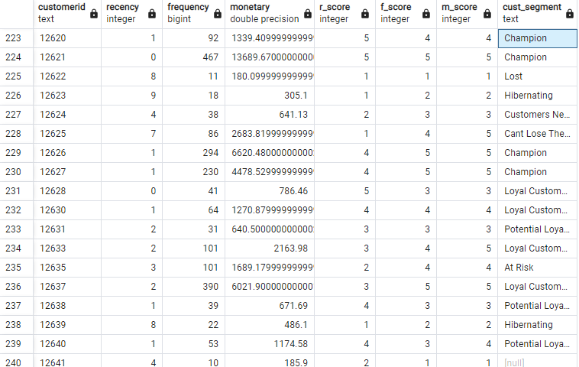

**🡪 in last column in last row , the customer segment is null**

**Because the range in table not contains value of 2,1 for r_score and avg f&m score.**